Little SPARK: Simple Play Adaptations to Reference for Kids

Wooden Marker Stand
Description: | Image:
This wooden marker stand holds 16 different Crayola (or similarly sized) markers. Keeps the lids safe while using the markers and is convenient for transporting markers. The stand measures 10 1/2 inches long x 3 3/4 inch wide and 1 3/4 inches high.  Purchasing Information | 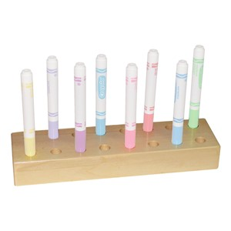

Who Might Benefit?
Those who demonstrate motor challenges around picking up a marker from a surface, lose track of lids, or are working on developing grasp.
Why Use?
An opportunity to easily view color choices, move multiple markers from place to place, recap markers independently, and easily pick up and grip marker.
Instructions for Use: | Adaptation Ideas:
Environmental Considerations  - Use in any environment on a flat surface.  Positioning  - Use in any position; seated, standing, on the floor.  Basic Play/Use Extended Play/Use  - Cap and put away markers. Matching marker colors to their caps.  Play/Use with Others  - Use in a shared space between students during drawing activities. | Stabilize It  - Use Dycem/shelf liner to secure.  Simplify It  - Reduce number of markers in stand.  Add Sensory Cues  - Add outline to marker hole with corresponding color.  - Add texture to marker holes for blind/low vision users to identify different colors.  Communication Supports  - Provide a communication board with vocabulary appropriate for the activity.  Alternative Uses  - Work on color and color word matching.

Words to Encourage Play/Use
Clean Up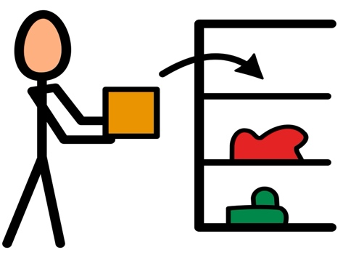 | Draw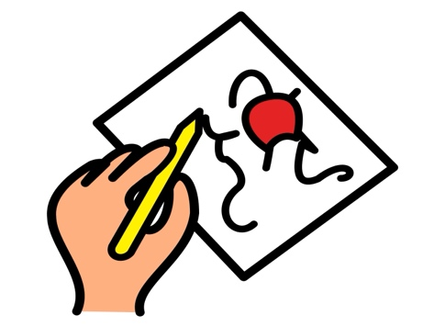 | Done
Share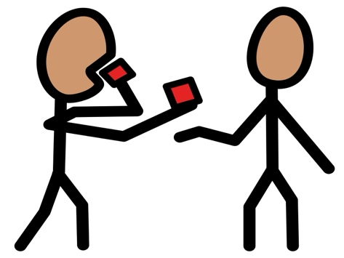 | Marker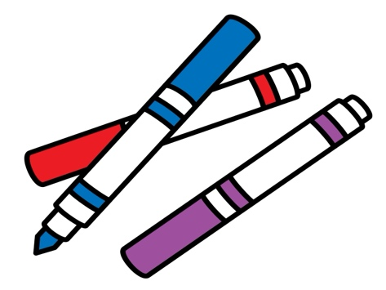 | Color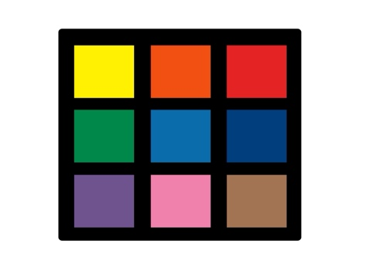
Help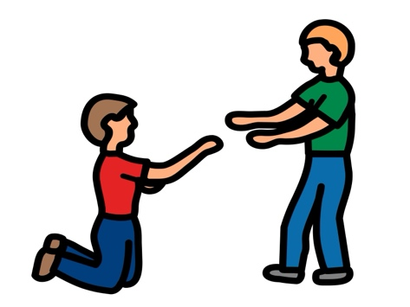 | Pull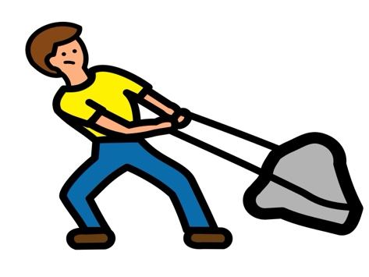 | Push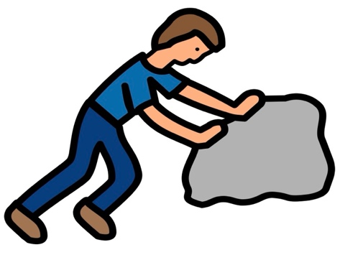
*”Adaptations” adapted from: Haugen’s Modes for Adapting Toys based on materials from the "Let's Play" Project at the University of Buffalo
PCS is a trademark of Tobii Dynavox, LLC. All rights reserved. Used with permission.

